REGISTRATION FORM

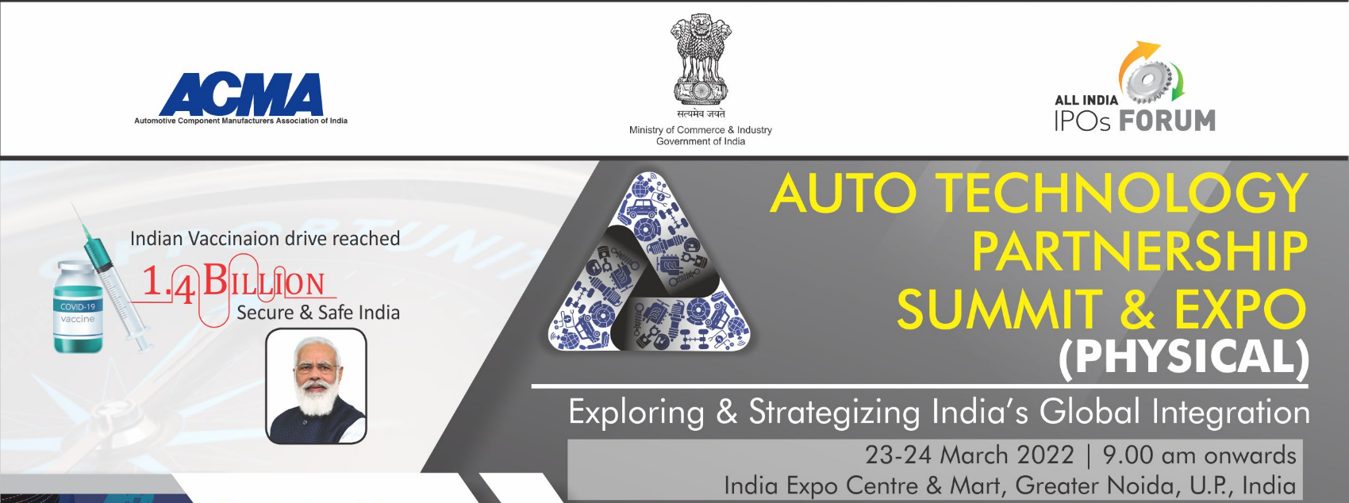

ACMA Scanned form to be sent: sapna.vijh@acma.in
6TH Floor, Mobile No. : +91-9873369063

The Capital Court, Olof Palme Marg, Munirka, New Delhi – 110067

Dear Sir,

Our Company confirms participation at Auto Technology Partnership Summit & Expo ( Physical )-“Exploring & strategizing India’s Global Integration”, and would like to nominate the following personnel from our organisation.

Name* Designation* E-mail id* Mobile Number*

Products Manufactured*:

Products for Partnering * (please mention below):
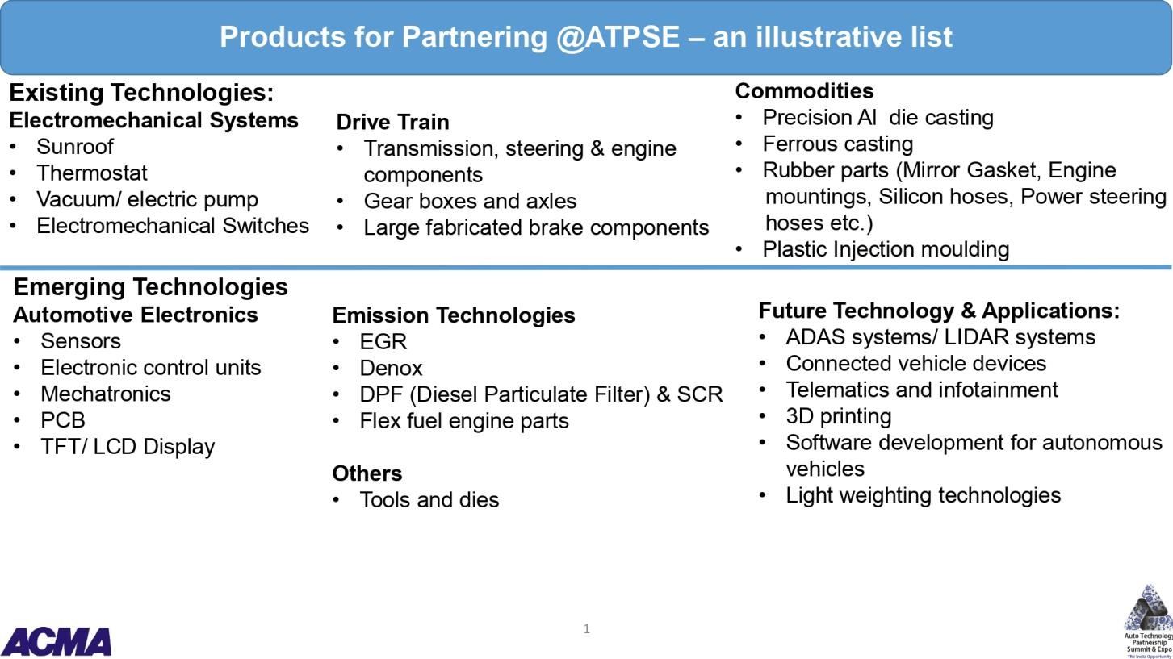

S. No. | Type of Collaboration | Please tick (Any 2) | Area of interest with product group
1 | Seeking Technical Collaboration/ Joint venture
2 | Explore export Opportunities
3 | Seeking opportunity for other tie up (Contract manufacturing/ M&A)
4 | Collaboration for EV components/ next generation mobility solutions

Please provide us with the following information of the company*:

IEC CODE: ; PAN NO: ; DIN NO:

Cost of Participation: Annexure I

Member: Rs.55,000/- + GST ( 18%)
Non Member: Rs. 65,000 + GST (18%)

Deliverables: 9 sq mt octonorm structure, fascia name, One round table, One info desk, three chairs, three spotlights, One wooden shelf, one podium, one waste-bin, one power socket, one info counter and carpet

SPONSORSHIP OPPORTUNITIES

Cost: Rs. 1,50,000/-

Deliverables:

- Standard booth (9 Sq mtr) at prime location
- 3 complementary Delegates.
- Colour advertisement in event catalogue ( inside insert )
- Logo in marketing collaterals : event website, inaugural backdrop and other branding areas
- 60 seconds corporate film on loop basis.

Bank Details:

DEMAND DRAFT / CHEQUE NO.  Dated AMOUNT:  (NON-REFUNDABLE)  TDS: BANK: DATED:  IN FAVOUR OF "AUTOMOTIVE COMPONENT MANUFACTURERS ASSOCIATION OF INDIA"  The transaction details to be shared to Ms. Sapna Vijh ( sapna.vijh@acma.in) |  | ACMA Bank detail for bank transfer :  Bank Account Name : Automotive Component Manufacturers Association of India  Account No. : 05882320000138  Bank Account Type: Current Bank Name: HDFC Bank  Bank Address: R.K.Puram, Sector-4,New Delhi MICR Code: 110240089  IFSC Code : HDFC0000588  UTRNO. DATE: AMOUNT: TDS
Invoicing Details
Name
Designation
Company
Address on Invoice
Mobile no.
GST Number as per Invoice
Address
Coordinator’s Name*: Designation*:

Organisation*:

Address*:

Tel. No*: Fax No: _

Mobile No*: E-Mail id*:

Signature: Date*:

  - Fields marked with * are mandatory.
  - The participation fee is non-refundable, however change in Nomination is allowed till two days before the program date.
  - Re-Confirmation email will be sent by ACMA.
  - Participants to represent the company booth must have complete dose of vaccination and send certificates along with the form
  - All safety protocol for COVID-19 would be followed at the exhibition site

